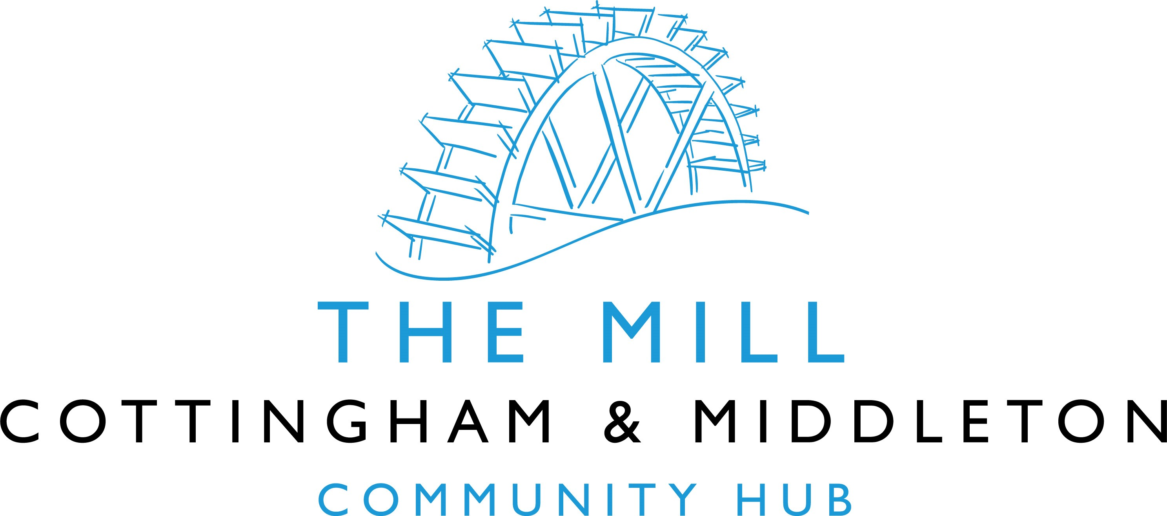

Annual General Meeting

Monday 13th Feb 2023, 6.00pm
Cottingham & Middleton Village Hall Annex

AGENDA
- Apologies for absence
- Minutes. Please note: The minutes of the AGM held on 16th March 2022 were signed off at OGM held on 27th April 2022 as is customary for this Board
- Confirmation and/or appointment of Trustees
- Appointment of Chair, Vice Chair and Treasurer
- Annual Report and Statement of Accounts

Annual Report 2022

This is the report of the outgoing Chair and Vice-Chair who have, in practice, acted as co-Chairs for the last two years. Several themes highlighted in the Annual reports for 2020 and 2021 set the scene for this last year. Particularly that:
- there is a post-Covid dearth of potential sources and opportunities for large scale capital funding for projects such as The Mill Community Hub.
- where possibilities do exist to apply for capital (e.g. the National Lottery) any grants awarded will be on a match-funded basis, with amounts granted likely to be limited to a maximum of £200k – £250k.
- the criteria for awarding capital grants for buildings, not surprisingly, now stress the use of sustainable materials that ensure a high degree of energy efficiency. The Trustees, of course, welcome the emphasis on carbon reduction but recognise that, to quite a significant extent, we will have to re-visit the original designs and plans to optimise their carbon-reduction potential without making changes which would void the planning permission granted in 2018.
The above points, together with the significant increase in costs of building materials and fuel, render several tenets of the Mill’s Business Plan, created over 4 years ago, out-of-date and in need of review. Accordingly, the Mill Trustees view it as critical to the success of the Mill project that:
- the car park phase proceeds apace – there are multiple benefits to the community for achieving this element of the project plan
- the Trustees of the Mill and of the existing Village Hall work together to develop the use of the existing venue towards it becoming, demonstrably, a well-supported and valued community facility. Being able, eventually, to evidence that the community’s use of, and need for, the current hall has outstripped its capacity will make the best possible Business Case for securing support and funding for a new, better equipped, building in the medium term future.
So, a strange year but not without its positives and advances by any means. We were delighted to welcome Leigh Morrell as a Trustee. Leigh had been attending meetings for a while and has shown then, and since, a skillset and levels of energy and enthusiasm that will greatly benefit the project going forward. This brought our complement up to the full strength of ten, as per our constitution.
We amended our constitution in July to incorporate such sensible improvements as requiring only one Trustee to be from each of the two Parish Councils (it was formerly two), and permitting up to two Trustees to be non-resident in either of the villages.
Since 31st March 2022 the Board has held five ordinary general meetings (27/04/22, 25/05/22, 29/06/22, 23/11/22, and 18/01/23).
Jo Leaning, our Treasurer-Trustee, has provided the Annual Finance Report accompanying this report. You will note that fundraising has brought in an income of £2,593.18. Tempting though it is to compare this unfavourably with the 2021 figure, the background contexts of 2021 and 2022 are so different as to make such comparison almost meaningless. Factoring in the well-publicised economic pressures, it is fantastic that the organisers of the Wine Tasting and Wine Safari events have supported the Mill so well. To all of you, and to all who contributed to the collections of coppers and Amazon Smile donations, a huge thank you.
Looking ahead, the Trustees are already stepping up plans to regain fundraising momentum, and will be organising some exciting fundraising schemes. Not least of these will be a Villages’ Fete on Saturday 15th July, another Wine Tasting evening in March and two quizzes in April and October. There is also talk of a Dog Show later in the year. Keep a look out for updates on these and other fundraising events on the usual local communications platforms.
Meanwhile, plans to meld and merge efforts and responsibilities between the two Trustee Boards is progressing well. The Village Hall Management Committee has very similar aims and objectives to those of The Mill Project and shortly we anticipate that ownership of the Village Acre (the site for the car park and Mill building) will pass to the Mill Trustees Board. It is useful to remind ourselves here what these are. Our registration with the Charities Commission (No. 1185835) states the Mill’s objects as:
“To further or benefit the residents of Cottingham and Middleton in Northamptonshire … to advance education and to provide facilities in the interests of social welfare for recreation and leisure time occupation with the objective of improving the conditions of life for the residents. In furtherance of these objects… the trustees shall have power… To establish or secure the establishment of a community centre and to maintain or manage or co-operate with any statutory authority in the maintenance and management of such a centre for activities promoted by the charity in furtherance of the above objects.”

There has been considerable activity on progressing the construction of the car park phase of the Mill project. We’ve had productive discussions with one of NNC’s senior planning officers and with a local architect about amending the existing tarmac-based plan to a much greener, eco-friendly solution. The issues are complex. We are looking to minimise the impact on the school’s boundary and Mill Road hedgerows whilst ensuring the safety of drivers and pedestrians. The construction elements of the Mill’s work are led very ably by Simon Hempson-Medwell and Mike Curtis. To date the quotes obtained for the various aspects of this work indicate that we will be able to afford it from existing resources. Scheduling when we might make a start on the actual work is difficult at present because we need to submit fresh drawings to NNC and because we have to avoid disrupting nesting birds. However, we aim to get this done in the 2023/24 period.

It just remains for us as outgoing Chairs, to pledge our continuing support to our successors in the coming year.

George West-Robinson and Sarah Brant
Co-Chairs of the Mill Community Hub, Cottingham and Middleton.

13th February 2023

